1. **Module A.1: Simon Game Icebreaker**

LEVEL 0

1)

1. My personal best score for the Simon game was 14.
2. In my group the personal best score was 20.
3. Good graphics, being able to play with many people and game that gets constant updates makes a good game.
4. Both some modern computer games and this Simon game require a lot of concentration and memorization

2)

1. By pressing different color buttons users input information into the game
2. The flashing lights and sounds are the output feedback to the players by the Simon game
3. Pass it or solo are the two different game modes options in the game
4. The only condition for stopping the game is pressing game or hitting the wrong button

LEVEL 1

1. Ralph Baer is the inventor of the Simon game
2. Simon game is based on “Touch Me”
3. The Brown Box was the first video game
4. Table tennis, Submarine, Analogic where the first game
5. The oldest game console I have played on was the game cube.
6. The old games had barley any content, were mostly black and white, and you could not play with people further than your console. The current games you have amazing 4k quality content, you are able to play with friends online around the world and get content new content added to the game so you won’t finish the game right away
7. Both old and modern games require strategy and both have visuals

**LEVEL 2**

|  |  |  |
| --- | --- | --- |
| **Object** | **Action** | **Description** |
| Red Button, Blue Button  Green Button, Yellow Button | Push/Press | Starts the game.  Record a step in the pattern.  Ends the game. |

**2)**

|  |  |  |
| --- | --- | --- |
| **Object** | **Action** | **Description** |
| Red Light, Green Light  Yellow Light, Blue Light | Flash | Shows the start of the game, a step in the pattern and the end of the game. |
| Red Sound, Blue Sound  Yellow Sound,Green Sound | Play Tone | Shows the start of the game, a step in the pattern and the end of the game. |

**3)**

|  |  |  |
| --- | --- | --- |
| **Input Object** | **Output Object** | **Process Connection** |
| Red Button, Blue Button  Yellow Button, Green Button | Red Light  Blue Light  Yellow Light  Green Light | Light flashes when the button is pressed. |

**LEVEL 3**

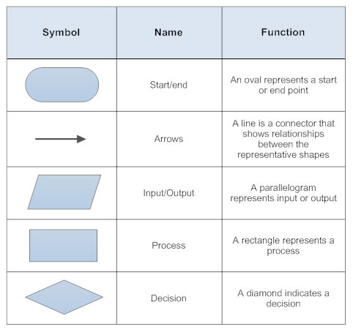

Output Action

Output Action

End

Start

Input Action

Input Action

Step 1

Decision

Yes

No

Step 2

**Level 4**

Start

Press any button to activate the game

Yes

Decision

Press Yellow Button

No

Action

Action

No

Yes

No

Yes

End

Step 2

Follow the pattern until you lose.

Step 1

Press the red button to play solo or press the yellow button to play pass it on multiplayer.

No

Yes

Action

Action

Decision

Press Red

Button

Action

Action

Decision

Press Yellow Button

End